**Day 7**

1. Rank employees by their total sales

(Total sales = Total no of orders handled, JOIN employees and orders table)

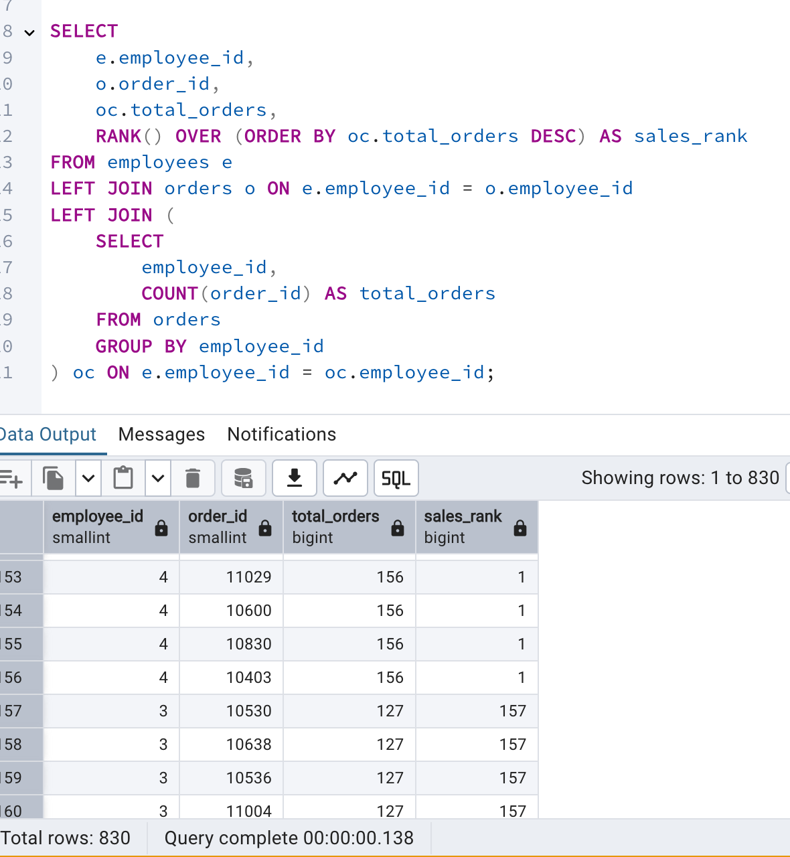

2. Compare current order's freight with previous and next order for each customer.

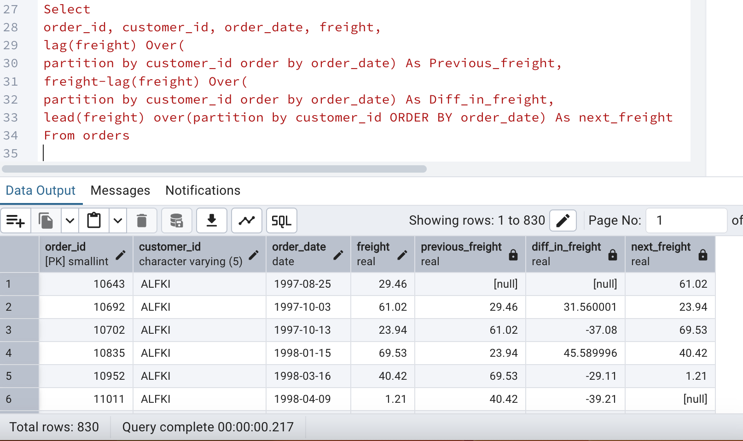

3. Show products and their price categories, product count in each category, avg price:

(HINT:

· Create a CTE which should have price_category definition:

WHEN unit_price < 20 THEN 'Low Price'

WHEN unit_price < 50 THEN 'Medium Price'

ELSE 'High Price'

· In the main query display: price_category, product_count in each price_category, ROUND(AVG(unit_price)::numeric, 2) as avg_price)

WITH pricecategories AS (

SELECT

product_id,

product_name,

unit_price,

CASE

WHEN unit_price < 20 THEN 'Low Price'

WHEN unit_price < 50 THEN 'Medium Price'

ELSE 'High Price'

END AS price_category

FROM

products

)

SELECT

price_category,

COUNT(*) AS product_count,

ROUND(AVG(unit_price)::numeric, 2) AS avg_price

FROM

pricecategories

GROUP BY

price_category

